**LAB NO 11**



**Fall 2024**

**CSE-304L Computer Organization and Architecture Lab**

Submitted by:

Name : **Hassan Zaib Jadoon**

Reg no**. : 22PWCSE2144**

ClassSection **: A**

Signature: ____________

Submitted to:

**Dr. Amaad Khalil**

**Department of Computer Systems Engineering**

**University of Engineering and Technology, Peshawar**

**Decoder:**

TASK1:

Write a Verilog code for 2x4 Decoder using Dataflow Level modeling.

CODE:

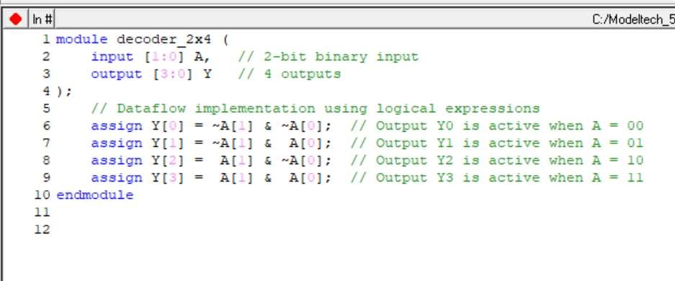

Output:

**Table:**

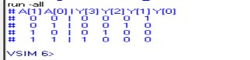

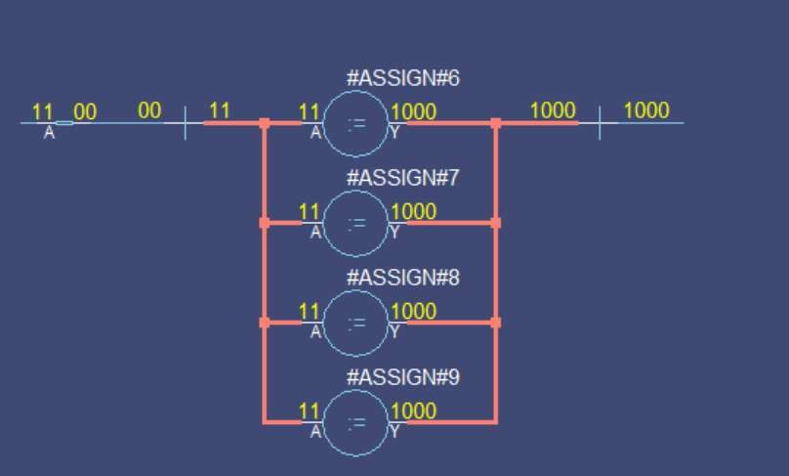

**Task 2:**

Write a Verilog code for 3x8 Decoder using Dataflow Level modeling.

**Code:**

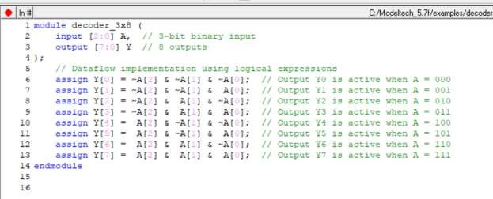

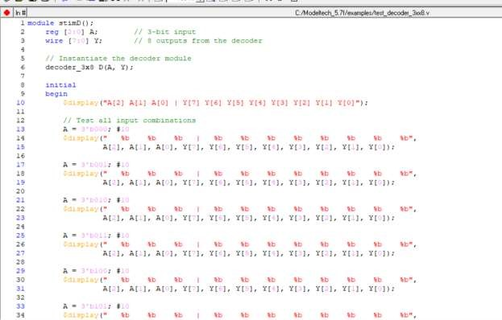

**Table output:**

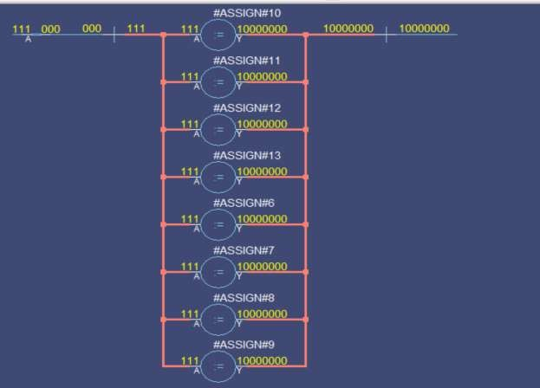

**TASK 3:**

Write a Verilog code for 4x16 Decoder using Dataflow Level modeling.

**Code:**

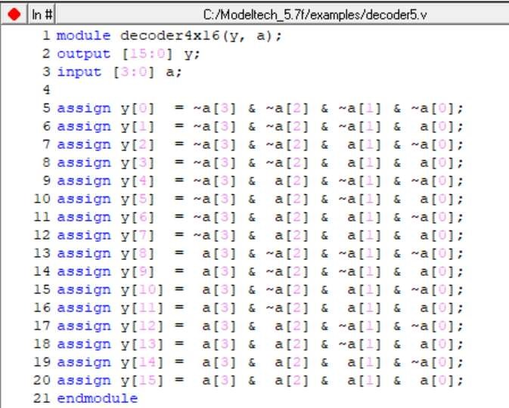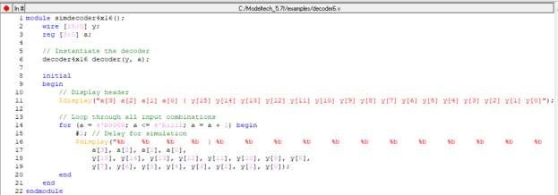

**Output:**

**Remarks:**

1. **Definition**: A decoder is a combinational circuit that converts binary input data into a specific output line, with only one output line active (logic 1) at a time.
2. **Purpose**: Decoders are commonly used in applications such as memory address decoding, data routing, and enabling specific devices in digital systems.
3. **Types**:
   * **2x4 Decoder**: Converts 2 input lines into 4 output lines.
   * **3x8 Decoder**: Converts 3 input lines into 8 output lines.
   * **4x16 Decoder**: Converts 4 input lines into 16 output lines. • Larger decoders, like 5x32, can also be constructed.
4. **Working Principle**: For an n-input decoder, exactly one of the 2^n output lines is active based on the binary input combination.